Conflict
- What is conflict
- Neither good nor bad; it all depends on the situation
- Conflict is a felt of struggle between two or more interdependent individuals over perceived incompatible different in belief, values and goals, or over differences in desire of esteem, control, and connectedness
Important element
Struggle
Is the result of opposite force come together
Interdependent
The conflict parties need to be interdependent in order to have some of their belief, value or something overlap, independent parties will not have chance to conflict
Felt (the affective element)
Felt is a emotional process, in the conflict there is arousal of feeling in both parties during the conflict, the felt upset and wants to defend their position
Report that emotional might include: feeling of sad, lonely, disconnected, and abandonment
Different
Each individual is unique therefore we have different in belief, values and goals, or over differences in desire of esteem, control, and connectedness
Conflict normally been discovered thought communication, when they express different or disagreement

- What is the types of conflict?
- Task or content conflict In the sample between Paul, David and Sally
This involved struggles between leaders and others who differ on issue such as policies and procedure

- Conflict on belief and values
- Belief and value form during the lift time, from or given by your environment, the image we give to the world
- We can easily known if people who have different viewpoint to you
- Belief example: animal test
- Value example; different in opinion in some investment decision

- Conflict regard to goals
- Individual have different goals
- Two types: procedure and substantive conflict
Procedure conflict between paul and David & Sally
Different in how they going to reach the goals
Not about what goals to reach
Eg : between three conflict employees, they disagree on the procedure one prefer planed ahead and two others prefer bouncing idea during the process

substantive conflict
Disagree on what goals should be, since different individual have different perspective to what is goals

- Relationship conflict
- esteem
everyone need to satisfy to fulfill their self-esteem though their behavior
we wish other to fell out behavior to be significant, useful and worthwhile but other don’t really think in that way, and some time each other’s esteem might overlap because what we can give to others are limited
- control
people want to feel be able to impact the surrounding and control has impact that lets use feel more competent and less helplessness
conflict arise when one’s need for control is incompatible to others need to control
- affiliation
different in feeling of closeness or involvement in a relationship might also cause problem

- Source of conflict
- Communication
- Ambiguity
- Scare of resource
- Task interdependence
- Different value
- Incompatible goals

- Styles of handling conflict
As in the case studies, we can see some kinds of avoiding in solving the problem because the problem exist long ago. However, as a leader not to be afraid and collaborating with the tema member to solve the problem is the most important
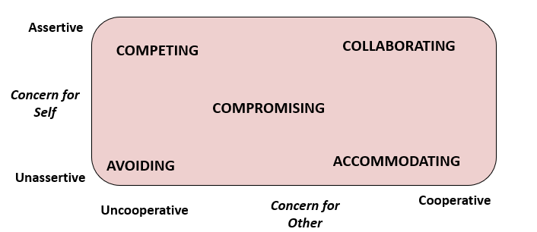
Avoiding style
- Stays away from conflict, ignores disagreements
Competing style
- Win-lose, coercion
Accommodating style
- Act as though the conflict will go away in time
Collaborating style
- Win-win style, open evaluation of conflict & search for solutions
Compromising style
- Give & take

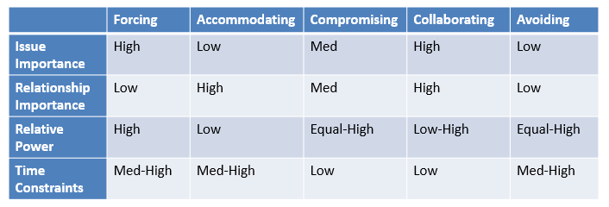

- How to manage conflict as leader
Four steps to manage the conflict
Problem identification solution generation action plan generation implementation and follow up

Key model to solve conflict (fisher and Ury)
- Separate the people with the problem
To separate relationship issue conflict with content conflicts
In the sample, as a leader we should dealing with the problem of work procedure and the personal issues separately. Try to solve the person problem first, separation allow individual to known the uniqueness of each one and understanding there is different in between peoples and how they work. And to put personal reason away allow individual to focus on the problem of work rather the thought of dislike
- Focus on interest not position
In the case this way allows conflict individual to discover the underpinning reason of why they need something (for example, do Paul like planed ahead because he need felling of securities and other need the feeling of social level need of represent value during the process)
This help to make the solving of conflict more authentic
- Invent option for mutual gain
Inventing of new solution that solve the problem for all and satisfy all
For the case studies, we can call a meeting for Paul, Davis and Sally to sit together to brainstorming the solution that can effectively solve the process problem
- Insist on using objectives criteria
The objective include the use of different standard, previous, professional, legal, moral, traditional and science judgement
for the case, leader can look at is there any previous solutions by the company to deal with these problem, looking for studies that solve these problem

key people involve
the important here is the effect of leader as mediator to both parties
- Initiator
In the problem identification stage
Succinctly describe your problem in terms of behaviours, consequences and feelings
avoid draw subjective conclusion
hold your word until understanding
encourage communication
Paul or David and sally known what they dislike about each other, did not know why and do not said I think he don’t like me in the beginning
- Responder
In the problem identification stage
shown interest and concern
seek information about the problem
agree with some aspect of the compliant
They both shown interest in solve the problem and do try to put attitude right and understand that they have different work flow and personal problem
- Mediator
In the problem identification stage
Acknowledge that a conflict exists and propose a problem-solving approach for resolving it
In seeking out the perspective of both parties, maintain a neutral posture regarding the disputants, if not the issues
Manage the discussion to ensure fairness
Solution Generation
encourage the solve of the problem not who fault it is
Focus on interest not position (mentioned above) can use the model above to said this part
make sure all pertise are fully aware the fact and understanding each other
follow up procedure and future plan

Steps
- Observation and discover of the problem
Either by yourself or someone come and tell you there is a problem
Between who and how
See is there any different types of problem exist
- Arrange a meeting with both parties together and make sure they are willing and interest in solve the problem before hand
In the meeting, allow them to express what they think and why they think
Try to separate the problem, guide the communication as a healthy vibe and lead them to mention more about why they are behaving differently
Barnstorming with both parties try to figure new way of work process and personal issue that led to both parties’ satisfaction
- Record all the agree opinion solution to a plan and show it to every one what they agree to if next they face the same conflict. For the work process, redesign the work process that fill everyone’s need
- Remember to keep observing see if there is any other conflict happened in the group and ask them for feedback of having this meeting, what they felt after

How it works with vision
- Vision is a more board idea of common goals, itself give the group a common goal and interest to self-sacrifices toward the goals, it might be that in the extreme way, a vision allows team member to put down the hate, but less realistic
- Conflict handling help to facilitate the function of vision and more efficiently in achieve the goals
- Together it allows the team to work smother and learning form each other in order to achieve the goal

